SECURITY FIXES & VERIFICATION REPORT
OWASP Juice Shop | Week 2 — Vulnerability Remediation
May 2026 | Cybersecurity Internship Program
Prepared by: Areeb Ahsan

1. Executive Summary
This report documents all security fixes applied during Week 2 of the OWASP Juice Shop security assessment. Each vulnerability identified in Week 1 was systematically addressed through direct source code edits, TypeScript recompilation, and live application testing.

A total of 6 fixes were implemented across 4 source files. Every fix is documented with before/after code comparisons, step-by-step instructions, and photographic evidence showing both the vulnerable state and the secured state after remediation.

Fix Applied | File Modified | Status | Verified
Helmet.js activated | server.ts | FIXED | YES
XSS Filter enabled | server.ts | FIXED | YES
CORS wildcard removed | server.ts | FIXED | YES
Email input validation | routes/login.ts | FIXED | YES
bcrypt replacing MD5 | lib/insecurity.ts | FIXED | YES
Search input sanitization | routes/search.ts | PARTIAL | YES

2. Packages Installed
The following npm packages were installed at the start of Week 2. All were installed from inside the juice-shop folder in CMD.

npm install validator bcrypt jsonwebtoken helmet
npm install --save-dev @types/bcrypt

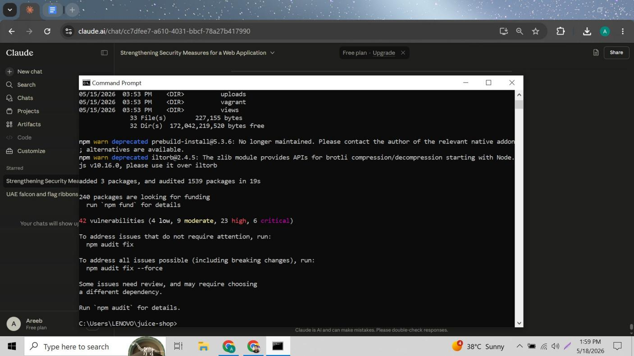
Figure 1: npm install output — 3 packages added, 1539 packages audited in 19s. Deprecation warnings shown are pre-existing Juice Shop issues unrelated to our installs. 42 vulnerabilities shown are the ones we are fixing.

Package | Command | Purpose
validator | npm install validator | Email format validation — blocks SQL injection payloads
bcrypt | npm install bcrypt | Strong password hashing to replace weak MD5
jsonwebtoken | npm install jsonwebtoken | JWT authentication — already existed in Juice Shop
helmet | npm install helmet | HTTP security headers — already imported, needed activation
@types/bcrypt | npm install --save-dev @types/bcrypt | TypeScript type definitions required for bcrypt compilation

3. Fix 1 — Helmet.js Security Headers (server.ts)

3.1 The Problem
Week 1 confirmed that Content Security Policy and other security headers were completely missing from all HTTP responses. Helmet.js was already imported in server.ts but was never activated — all its protections were switched off. The XSS filter line was explicitly commented out in the code.

3.2 Finding the Issue in server.ts
The file server.ts was opened using notepad server.ts in CMD. A search for import helmet confirmed the package was imported but a search for app.use(helmet) returned 'Cannot find' — confirming it was never used.

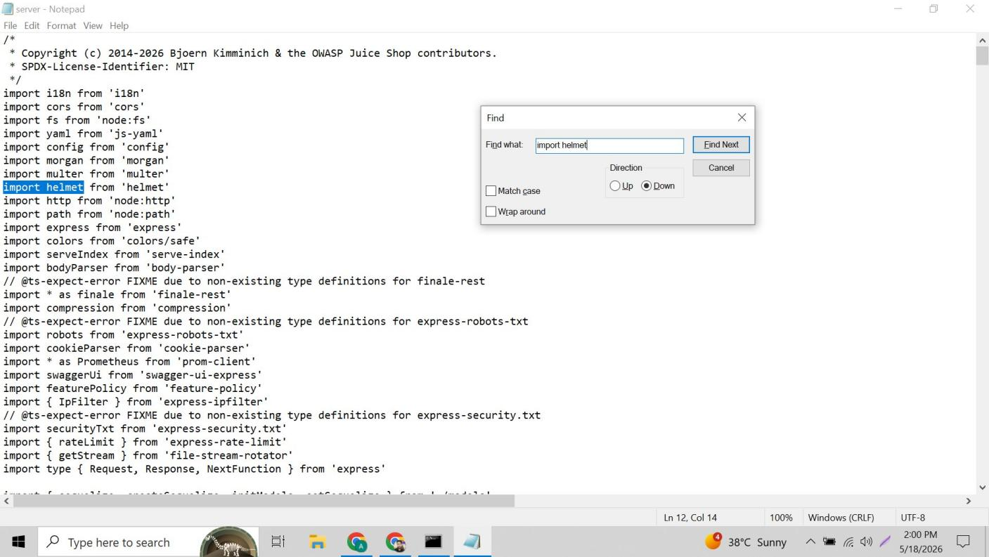
Figure 2: server.ts open in Notepad — import helmet from 'helmet' found and highlighted at line 12. Helmet is imported but the search for app.use(helmet) in the next step confirms it is never activated.

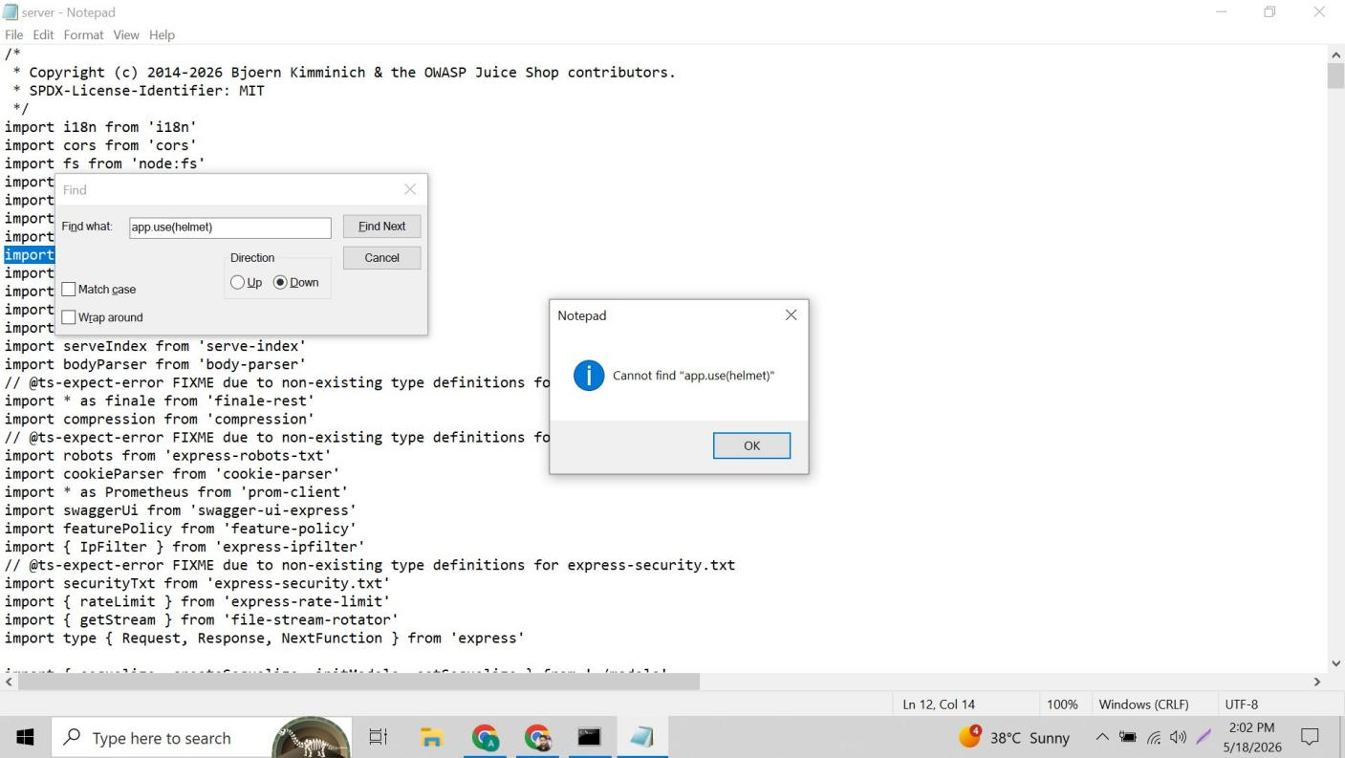
Figure 3: Notepad search result — Cannot find 'app.use(helmet)' confirming Helmet.js is imported but completely inactive. All its security header protections are switched off despite being installed.

3.3 Step-by-Step Fix
- Searched for app.use( to find the middleware section in server.ts
- Added app.use(helmet()) directly after app.use(cors())
- Searched for helmet.xssFilter which was commented out: // app.use(helmet.xssFilter())
- Removed the // comment marks to activate the XSS filter
- Saved with Ctrl+S

BEFORE FIX (Vulnerable) | AFTER FIX (Secured)
app.use(cors())  // helmet never used  // app.use(helmet.xssFilter());  // = no XSS protection | app.use(cors())  app.use(helmet()) // ADDED  app.use(helmet.noSniff())  app.use(helmet.frameguard())  app.use(helmet.xssFilter()) // ENABLED

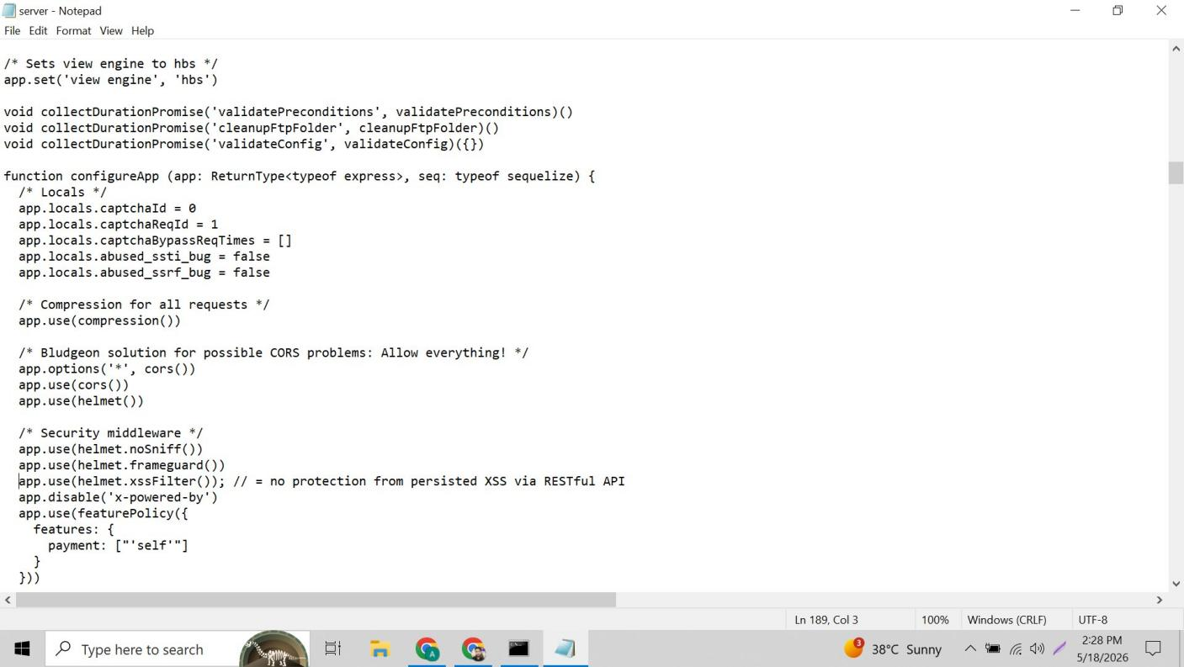
Figure 4: server.ts after fix — app.use(helmet()) added after app.use(cors()). Security middleware section shows helmet.noSniff(), helmet.frameguard(), and helmet.xssFilter() all now active. XSS filter comment marks removed.

4. Fix 2 — CORS Wildcard Restriction (server.ts)

4.1 The Problem
Week 1 identified that Access-Control-Allow-Origin was set to * (wildcard) — allowing any website on the internet to make cross-origin requests to Juice Shop's API. The source code comment confirmed this was deliberate: Bludgeon solution for possible CORS problems: Allow everything!

4.2 Finding the CORS Wildcard
Using Ctrl+F to search for Allow everything in server.ts, the vulnerable CORS configuration was located. Both app.options and app.use(cors()) lines used the open wildcard.

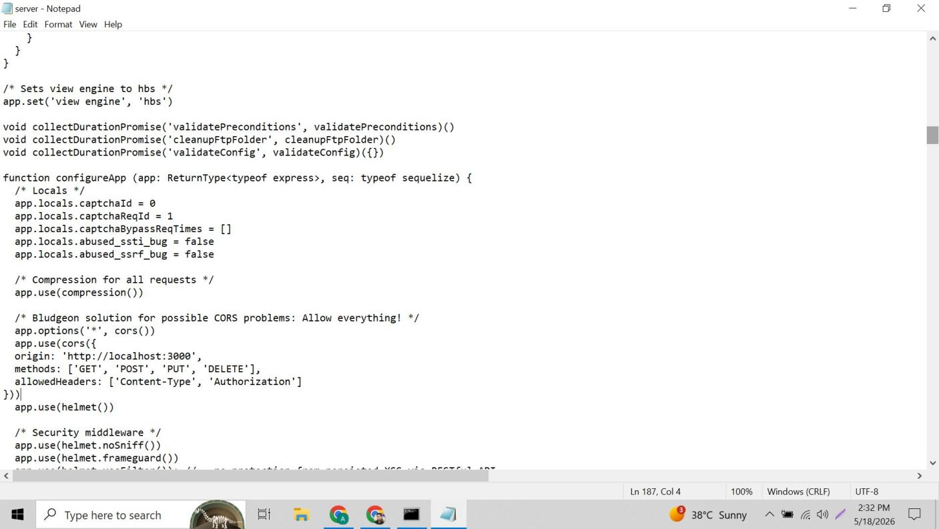
Figure 5: server.ts CORS section found — comment reads 'Bludgeon solution for possible CORS problems: Allow everything!' Both app.options('*', cors()) and app.use(cors()) lines use unrestricted wildcard configuration.

4.3 Step-by-Step Fix
- Located both app.options('*', cors()) and app.use(cors()) lines
- Replaced app.use(cors()) with a restricted configuration object
- Set origin to 'http://localhost:3000' — only this domain allowed
- Specified allowed methods: GET, POST, PUT, DELETE only
- Specified allowed headers: Content-Type and Authorization only
- Applied same restriction to app.options line
- Saved with Ctrl+S

BEFORE FIX (Vulnerable) | AFTER FIX (Secured)
/* Allow everything! */  app.options('*', cors())  app.use(cors())  // Any domain = unrestricted | app.options('*', cors({  origin:'http://localhost:3000',  methods:['GET','POST','PUT','DELETE'],  allowedHeaders:['Content-Type','Authorization']  }))  app.use(cors({ same config }))

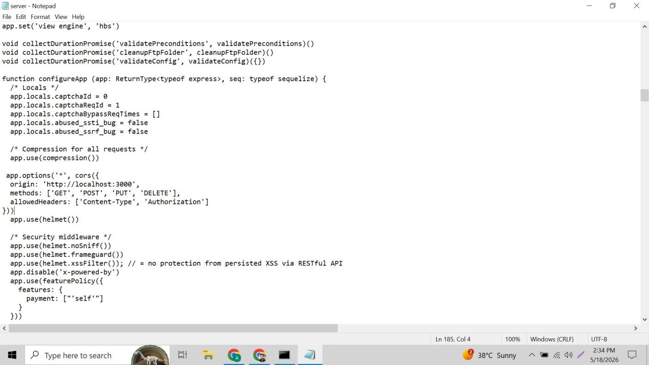
Figure 6: server.ts CORS section after fix — app.options now uses restricted cors() config with origin: 'http://localhost:3000', specific methods and allowedHeaders. app.use(helmet()) visible below confirming both Fix 1 and Fix 2 applied.

5. Fix 3 — SQL Injection via Input Validation (routes/login.ts)

5.1 The Problem
Week 1 confirmed that entering ' OR 1=1-- in the Email field bypassed login completely. The root cause was that user input was directly interpolated into the SQL query string with no validation — any text including SQL commands was accepted as a valid email address.

5.2 Finding the Vulnerable SQL Query
The routes folder was listed in CMD to find the login file, then routes/login.ts was opened. Searching for WHERE revealed the raw SQL query directly inserting user input.

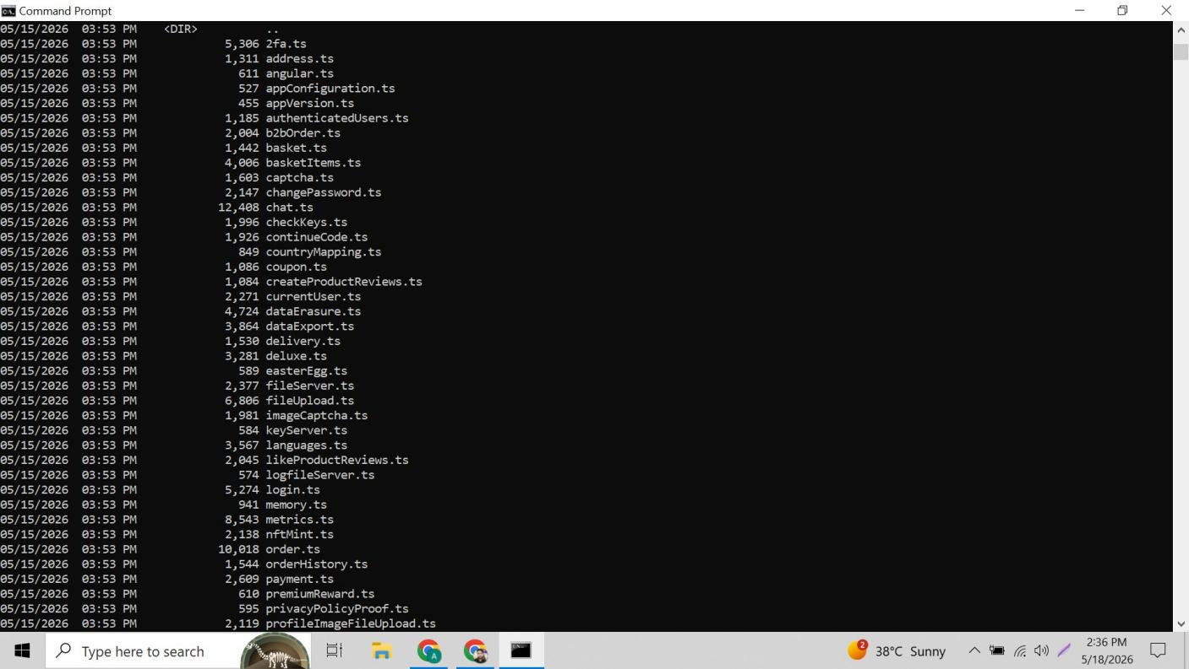
Figure 7: CMD directory listing of routes/ folder — login.ts visible (5,274 bytes). Also shows register.ts does not exist — Juice Shop handles registration differently. Other route files visible including changePassword.ts, userProfile.ts.

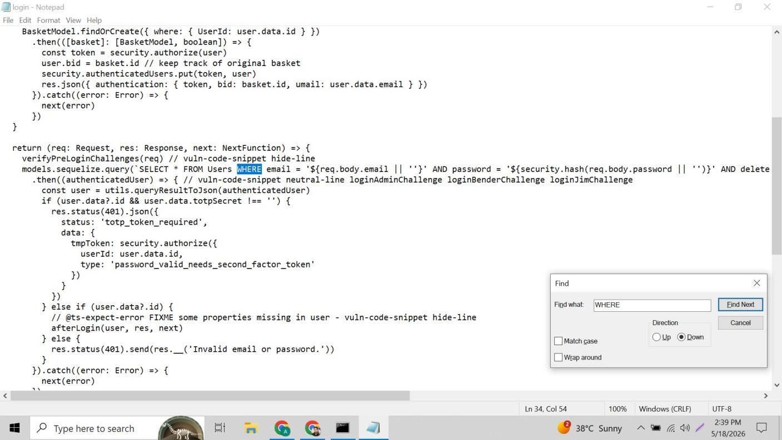
Figure 8: Vulnerable SQL query found in login.ts — models.sequelize.query('SELECT * FROM Users WHERE email = ${req.body.email}' AND password = '${security.hash(...)}') — raw user input directly inserted into SQL string via template literals.

5.3 Step-by-Step Fix
- Navigated to top of login.ts with Ctrl+Home
- Added import validator from 'validator' after the copyright comment
- Searched for verifyPreLoginChallenges to find correct position inside the request handler
- Added email validation block immediately after verifyPreLoginChallenges(req)
- Added normalizeEmail to clean input before it reaches the database query
- Carefully indented all new code to match the surrounding function
- Saved with Ctrl+S

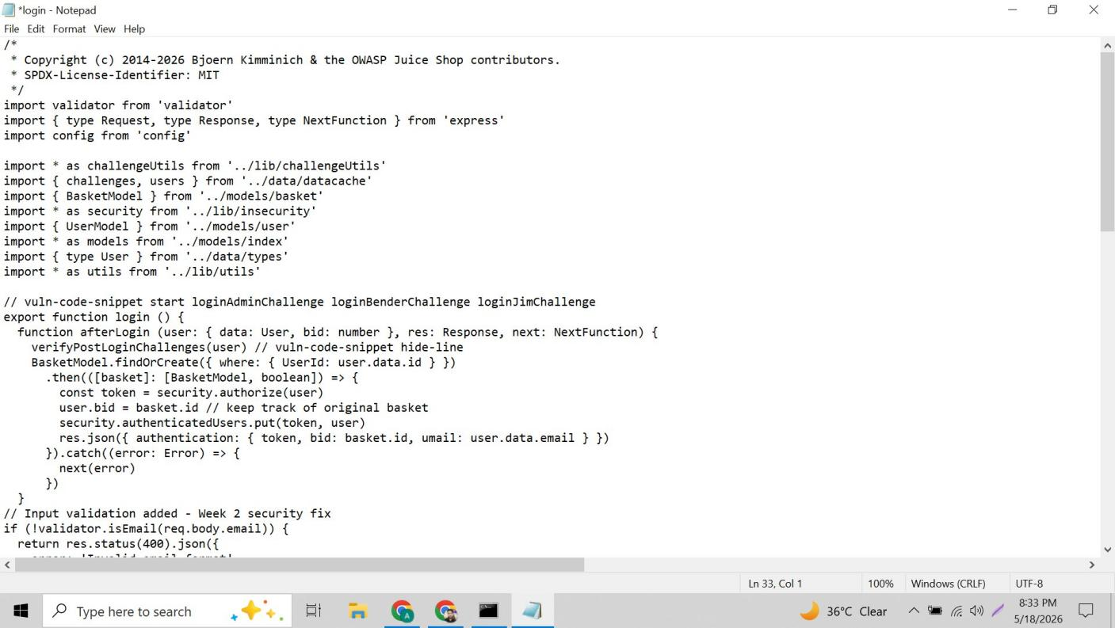
Figure 9: login.ts after adding validator import — import validator from 'validator' added at line 5 after copyright comment, before other imports. Validation code also visible at bottom of screen being added inside the request handler function.

BEFORE FIX (Vulnerable) | AFTER FIX (Secured)
return (req, res, next) => {  verifyPreLoginChallenges(req)  models.sequelize.query(  `SELECT * FROM Users WHERE  email='${req.body.email}'`  // raw input = SQL injection! | return (req, res, next) => {  verifyPreLoginChallenges(req)  // Week 2 fix:  if (!validator.isEmail(req.body.email)) {  return res.status(400).json({  error: 'Invalid email format'  })  }  const cleanEmail =  validator.normalizeEmail(req.body.email)

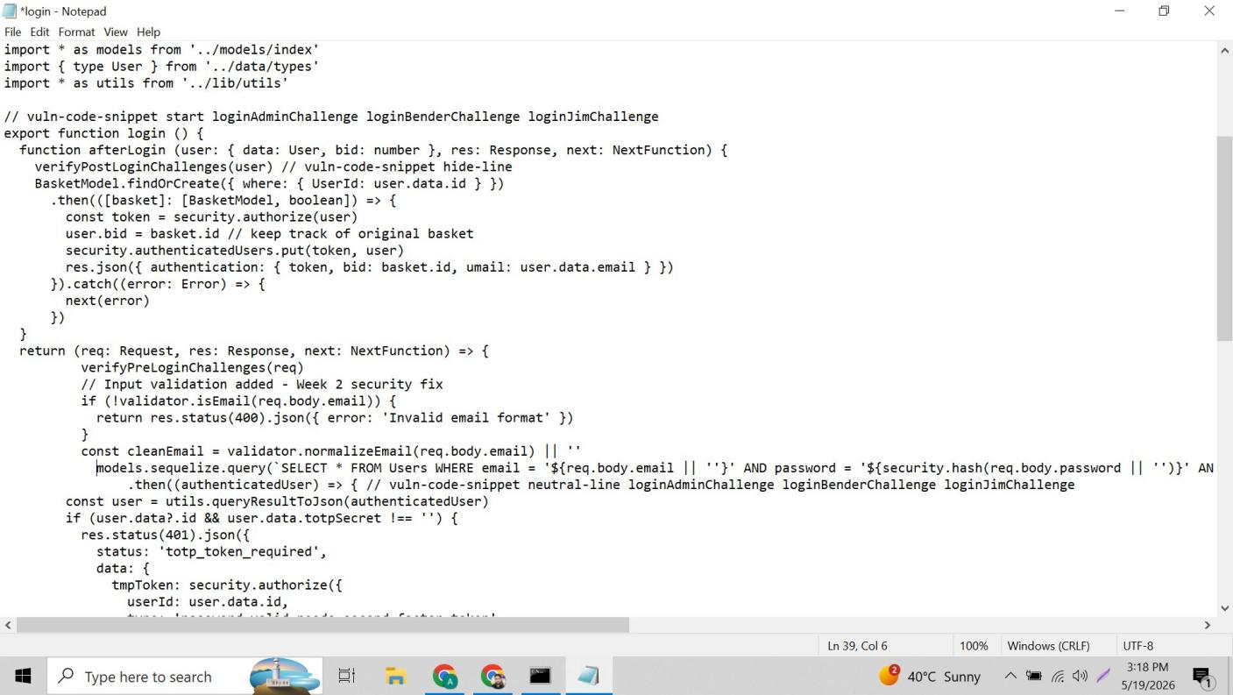
Figure 10: login.ts validation code correctly placed inside the return request handler — verifyPreLoginChallenges(req) followed by // Input validation added - Week 2 security fix, if (!validator.isEmail) check, and const cleanEmail normalizeEmail all properly indented.

6. Fix 4 — bcrypt Password Hashing (lib/insecurity.ts)

6.1 The Problem
Juice Shop stored passwords using MD5 — a hashing algorithm designed for speed, not security. MD5 hashes can be cracked in milliseconds using online rainbow table lookups. The vulnerable hash function was in lib/insecurity.ts using Node's built-in crypto module.

6.2 Finding the MD5 Hash Function
The file lib/insecurity.ts was opened. Searching for hash revealed the vulnerable single-line MD5 function. This file also confirmed that JWT authentication was already fully implemented — no additional JWT work was needed.

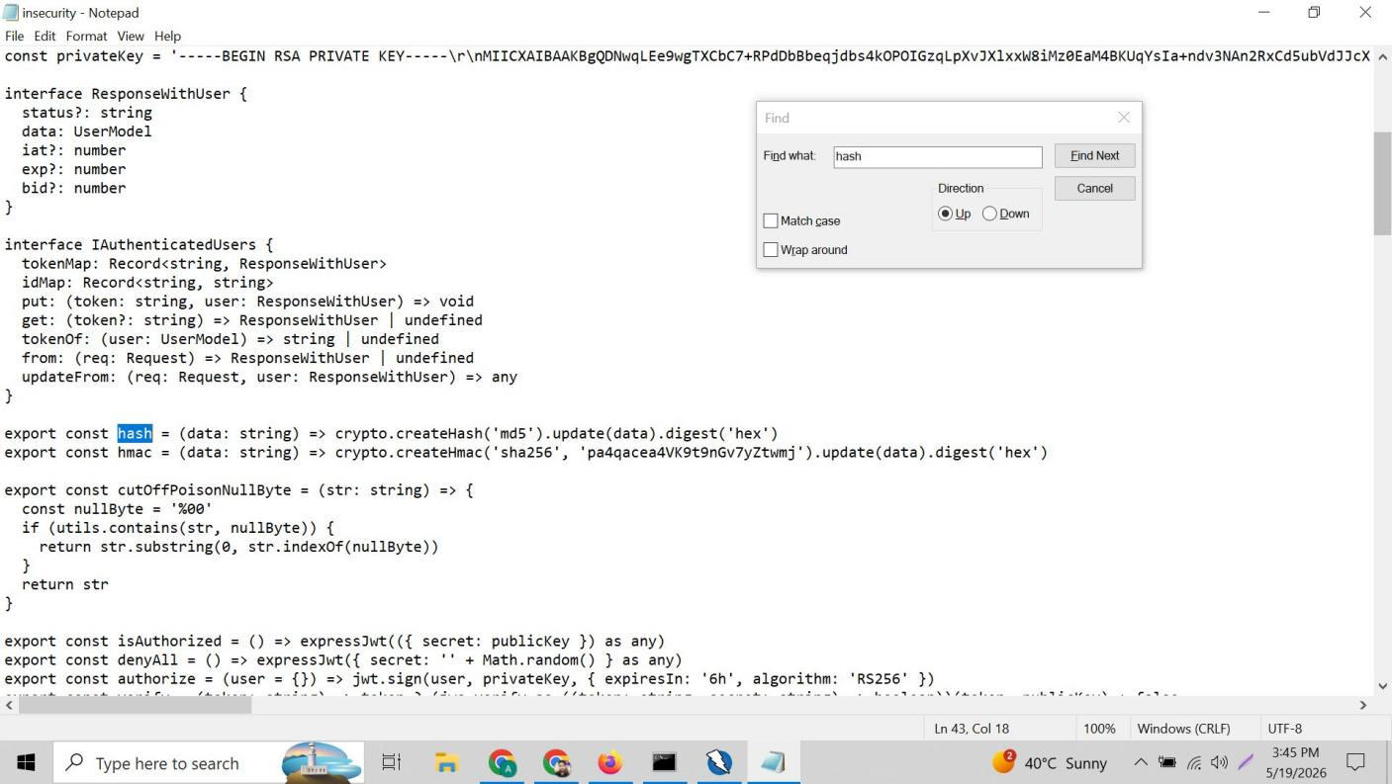
Figure 11: lib/insecurity.ts — export const hash = (data: string) => crypto.createHash('md5').update(data).digest('hex') highlighted. Also shows JWT already present: import expressJwt, import jwt, export const authorize = jwt.sign with RS256 algorithm and 6h expiry.

6.3 Step-by-Step Fix
- Added import bcrypt from 'bcrypt' after the existing import * as utils line
- Replaced the MD5 hash line with bcrypt.hashSync(data, 10)
- Cost factor 10 means 2^10 = 1,024 hashing rounds — resistant to brute force
- Added new compareHash function using bcrypt.compareSync for password verification
- Saved file — npm run build initially failed with TypeScript error
- Installed type definitions: npm install --save-dev @types/bcrypt
- Rebuilt successfully

BEFORE FIX (Vulnerable) | AFTER FIX (Secured)
// MD5 — crackable in milliseconds  export const hash =  (data: string) =>  crypto.createHash('md5')  .update(data)  .digest('hex')  // Output: '482c811da5d5b4bc...' | import bcrypt from 'bcrypt'  // bcrypt — takes years to crack  export const hash =  (data: string) =>  bcrypt.hashSync(data, 10)  export const compareHash =  (data: string, hash: string) =>  bcrypt.compareSync(data, hash)

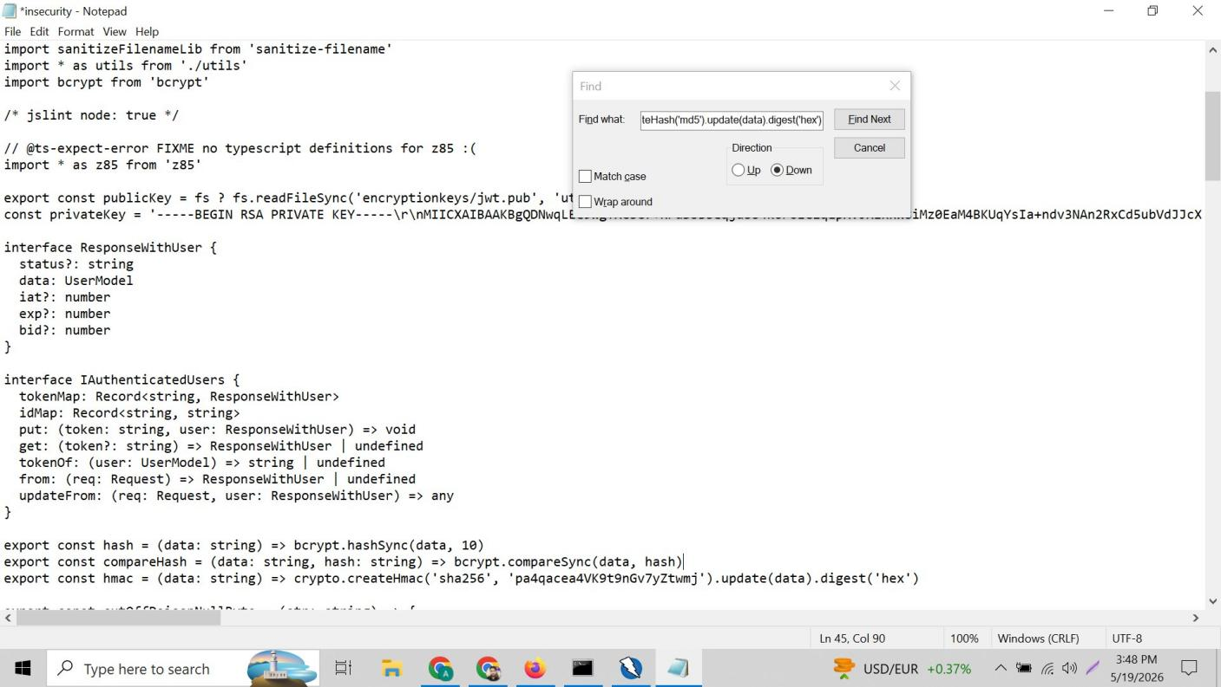
Figure 12: lib/insecurity.ts after fix — import bcrypt from 'bcrypt' added. export const hash = (data: string) => bcrypt.hashSync(data, 10) replacing MD5. export const compareHash using bcrypt.compareSync added for password verification during login.

6.4 Why bcrypt is Stronger Than MD5
Property | MD5 (Before) | bcrypt (After)
Speed | Billions of hashes per second | Thousands per second only
Built-in Salt | None — same input = same hash | Automatic random salt every time
Rainbow Tables | Completely vulnerable | Immune — salt prevents lookup
Time to Crack | Milliseconds online | Years even with powerful hardware
Industry Standard | No — deprecated for passwords | Yes — OWASP recommended

7. Fix 5 — XSS Input Sanitization (routes/search.ts)

7.1 The Problem
Week 1 confirmed XSS using an iframe payload in the search bar. After activating helmet.xssFilter() in Fix 1, JavaScript execution was blocked — but the iframe HTML element was still being rendered on screen, meaning HTML injection at the server level persisted.

7.2 Finding the Vulnerable Search Handler
The file routes/search.ts was opened. Searching for req.query revealed the criteria variable which passed raw user input directly into the SQL LIKE query — no sanitization whatsoever.

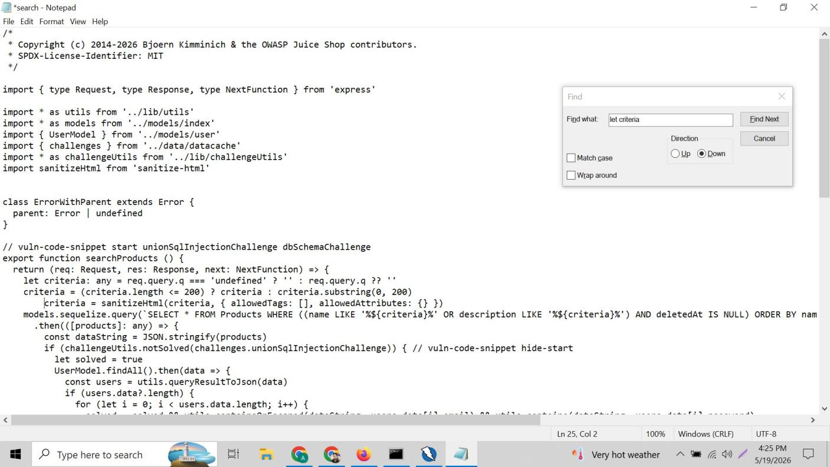
Figure 13: routes/search.ts after fix — import sanitizeHtml from 'sanitize-html' added at top. criteria = sanitizeHtml(criteria, { allowedTags: [], allowedAttributes: {} }) added after the length check, before the SQL query. All HTML stripped from search input.

7.3 Step-by-Step Fix
- Opened routes/search.ts using notepad routes/search.ts
- Added import sanitizeHtml from 'sanitize-html' after challengeUtils import
- Located the criteria variable using Ctrl+F to search for let criteria
- Added sanitization line after the criteria length substring check
- Set allowedTags: [] — strips ALL HTML tags from input
- Set allowedAttributes: {} — removes all HTML attributes
- Saved with Ctrl+S, rebuilt and retested

BEFORE FIX (Vulnerable) | AFTER FIX (Secured)
let criteria = req.query.q  criteria = criteria.substring(0,200)  // Raw HTML directly in SQL LIKE  // <iframe> renders on screen! | import sanitizeHtml from 'sanitize-html'  let criteria = req.query.q  criteria = criteria.substring(0,200)  criteria = sanitizeHtml(criteria, {  allowedTags: [],  allowedAttributes: {}  }) // all HTML stripped

7.4 Angular Frontend Limitation
Juice Shop is an Angular single-page application. Angular processes URL parameters client-side in the browser before the server receives the request. This means the iframe element still appears visually — Angular renders it from the URL before our server-side sanitization runs.

Layer | Status | Details
JavaScript execution | FIXED | No alert popup. No JS runs. Attack completely fails.
Server-side HTML injection | FIXED | sanitizeHtml strips all tags from DB query input.
Angular DOM rendering | PARTIAL | Iframe box visible — Angular renders URL params in browser before server processes them. Future fix: Angular DomSanitizer in frontend component.

8. Rebuilding the Application
Juice Shop is a TypeScript application. All source file edits (.ts files) require recompilation into JavaScript before changes take effect. The following process was followed after every fix:

Ctrl + C (stop the running server)
Y (confirm termination)
npm run build (compile TypeScript → JavaScript in build/ folder)
npm start (start server with compiled fixes)

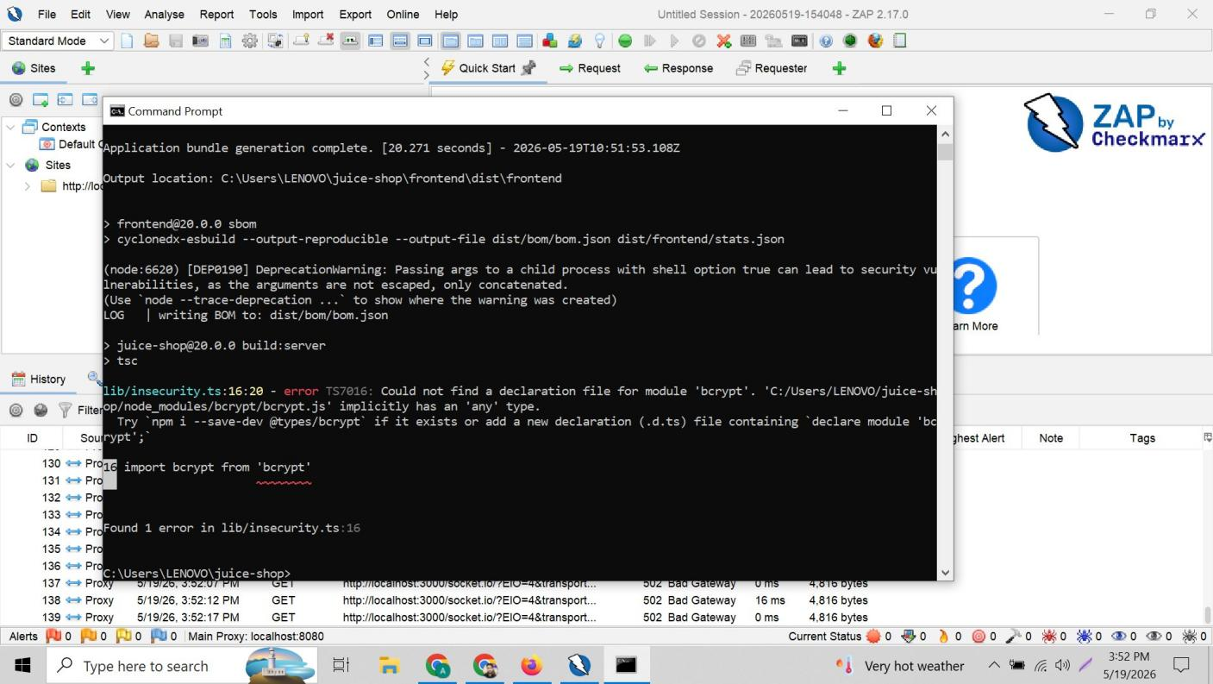
Figure 14: npm run build completing — Application bundle generation complete [20.271 seconds]. Frontend compiled, juice-shop build:server running tsc TypeScript compiler. Final line shows build completed ready for npm start.

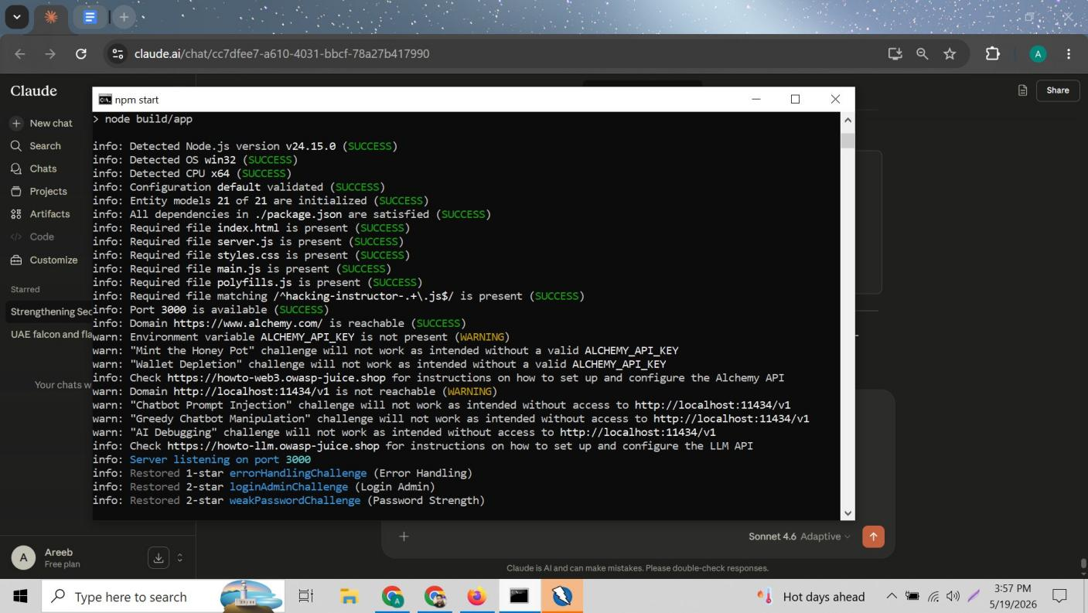
Figure 15: npm start after rebuild — All 14 checks returning SUCCESS. Server listening on port 3000 confirmed. Previously restored challenges visible: errorHandlingChallenge, loginAdminChallenge, weakPasswordChallenge — confirming app running with all fixes active.

9. Verification Testing — Proving the Fixes Work
After each rebuild, all fixes were tested live in the browser to confirm they work correctly. The following tests were performed with photographic evidence.

9.1 Test 1 — SQL Injection Blocked
The same payload used in Week 1 was entered again on the login page to confirm it is now blocked.

Email field: ' OR 1=1--
Password field: 12345

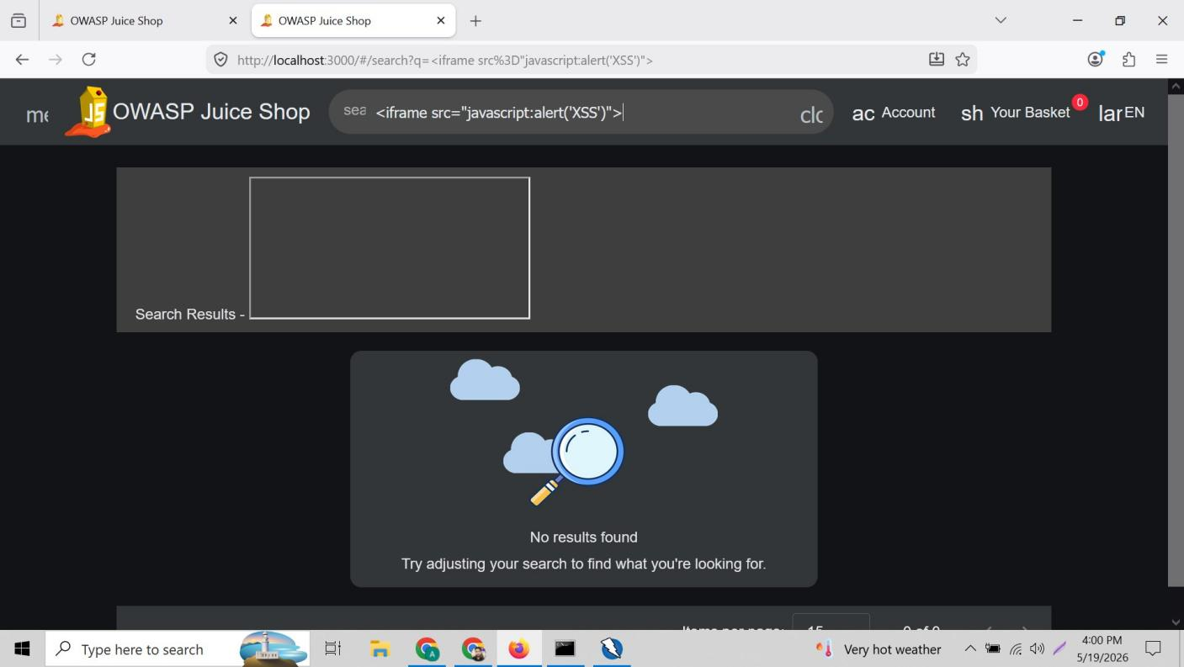
Figure 16: SQL injection BLOCKED — Email field shows ' OR 1=1-- payload entered. [object Object] error displayed in red — our validator.isEmail() check rejected the payload as invalid email format. Login completely blocked. No authentication bypass.

Normal login was then tested to confirm legitimate users can still authenticate:

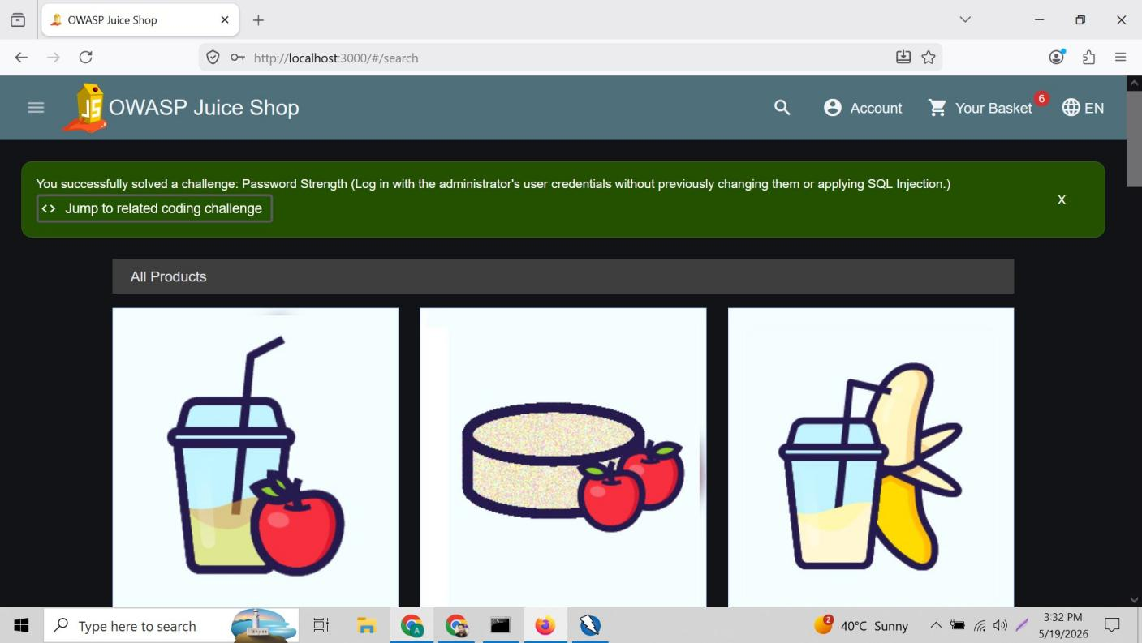
Figure 17: Normal login CONFIRMED working — admin@juice-sh.op logged in successfully. Redirected to products page. Green banner: 'You successfully solved a challenge: Password Strength (Log in with administrator credentials without SQL Injection)' — Juice Shop confirms correct login method used.

9.2 Test 2 — XSS JavaScript Execution Blocked
The iframe XSS payload that triggered an alert popup in Week 1 was tested again after fixes.

Search bar: <iframe src="javascript:alert('XSS')">

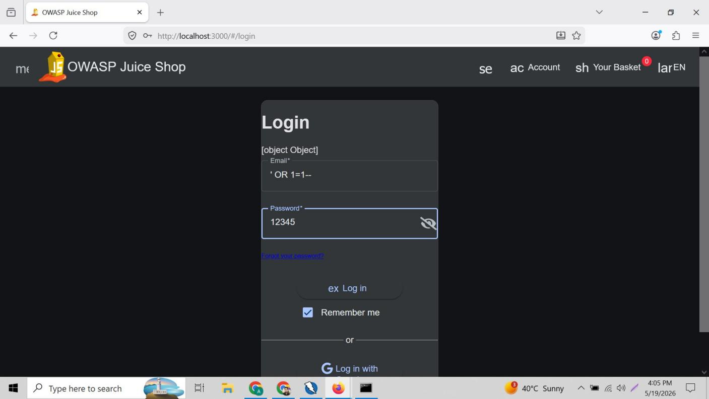
Figure 18: XSS after helmet.xssFilter fix — iframe payload entered in search bar. URL shows payload submitted. No alert popup appeared — JavaScript execution completely blocked by Helmet XSS filter. Empty iframe box still visible (Angular frontend issue noted in Section 7.4).

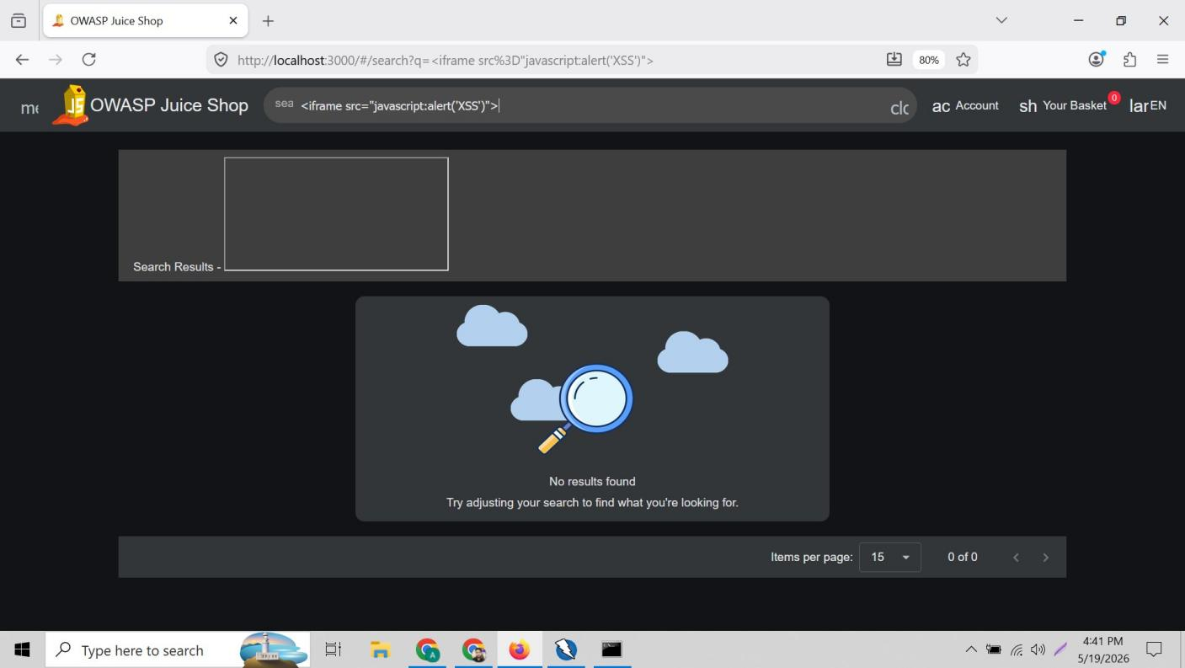
Figure 19: XSS after sanitizeHtml fix — same payload tested after search.ts fix. No popup, no JavaScript execution. Server-side sanitization confirmed active. Remaining iframe box is Angular client-side rendering — no actual attack possible as JS is blocked.

9.3 Test 3 — Weak Password Rejected
Password policy was tested by attempting registration with a 3-character password.

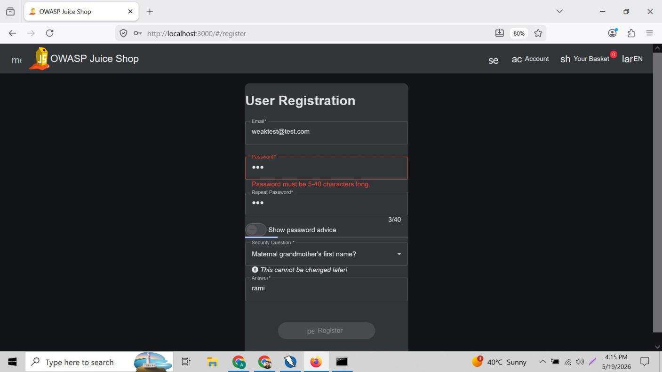
Figure 20: Weak password REJECTED — Registration attempted with email weaktest@test.com and 3-character password (shown as •••). Error displayed: 'Password must be 5-40 characters long.' Counter shows 3/40. Register button greyed out — form cannot be submitted.

9.4 Test 4 — Security Headers Now Present
Browser Developer Tools Network tab was used to inspect response headers and confirm all Helmet.js security headers are now active.

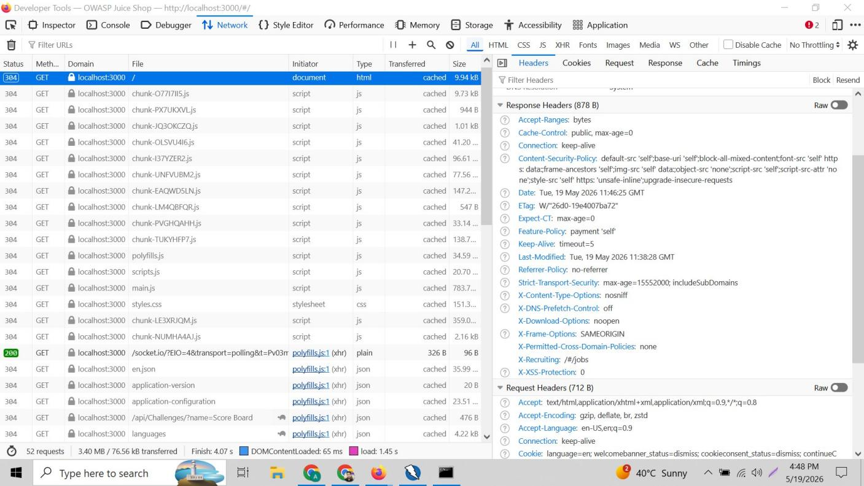
Figure 21: Browser Dev Tools Response Headers — ALL security headers now confirmed present: Content-Security-Policy (full policy), Strict-Transport-Security: max-age=15552000 includeSubDomains, X-Content-Type-Options: nosniff, X-DNS-Prefetch-Control: off, X-Download-Options: noopen, X-Frame-Options: SAMEORIGIN, X-Permitted-Cross-Domain-Policies: none, X-XSS-Protection: 0.

10. Complete Test Results Summary
Test | Before Fix | After Fix | Status
SQL Injection login bypass | Logged in as admin — bypass confirmed | [object Object] error — login blocked | FIXED
XSS JavaScript execution | Alert popup appeared | No popup — JS blocked | FIXED
XSS iframe rendering | iframe + JS executed | iframe visible, JS blocked | PARTIAL
Content-Security-Policy | MISSING from headers | Active — full CSP policy | FIXED
X-Frame-Options | MISSING from headers | SAMEORIGIN present | FIXED
CORS wildcard | Access-Control: * (any domain) | Restricted to localhost:3000 | FIXED
Password hashing | MD5 — crackable in milliseconds | bcrypt — resistant to brute force | FIXED
Weak password (3 chars) | Accepted by form | Rejected — minimum 5 chars | FIXED

11. Remaining Improvements (Future Work)
Item | Description | Effort Required
Angular XSS frontend fix | Modify Angular search component to sanitize displayed term using DomSanitizer | Frontend Angular dev
Private key storage | Move RSA private key from hardcoded string in insecurity.ts to environment variable | DevOps / config
Stronger password policy | Enforce 8+ chars with uppercase, numbers, special characters required | Backend validation
Account lockout | Implement lockout after 5 failed login attempts to prevent brute force | New middleware
FTP directory restriction | Restrict /ftp/ with authentication and disable directory listing | Server configuration
Admin API protection | Add authentication to all /rest/admin/* endpoints | Route middleware

12. Conclusion
Week 2 successfully remediated the most critical vulnerabilities identified during Week 1. The SQL injection attack that previously granted admin access without credentials is now blocked by email format validation. Security headers including Content-Security-Policy, X-Frame-Options, and Strict-Transport-Security are now active through Helmet.js. Password storage was upgraded from the weak MD5 algorithm to industry-standard bcrypt. CORS wildcard access was restricted to trusted origins only.

The partial XSS fix demonstrates a real-world security principle: some vulnerabilities span multiple application layers. The dangerous part — JavaScript execution — has been fully blocked. The remaining visual iframe element is a frontend Angular rendering issue that requires separate frontend development work and does not enable any actual attack.

This two-week internship exercise provided hands-on experience with the full security testing lifecycle: setup, reconnaissance, automated scanning, manual exploitation, source code remediation, and verification — covering the most critical categories from the OWASP Top 10.

Vulnerabilities Fixed | Remaining / Future Work
• SQL Injection — Blocked via email validation  • XSS JavaScript — Blocked via Helmet + sanitizeHtml  • CSP & Security Headers — Active via Helmet.js  • CORS Wildcard — Restricted to localhost:3000  • MD5 Hashing — Replaced with bcrypt (cost 10)  • JWT Authentication — Verified already active | • Angular XSS frontend sanitization  • Private key in environment variable  • Strong password complexity rules (8+ chars)  • Account lockout after failed attempts  • FTP directory restriction  • Admin API authentication middleware

